**Design Brief and Competitive Analysis of Tidal Music**

INFO 608

Group 4

Seemron Bhuyan

Megan Cunningham

Ramar Huntley

Trevon Walker

**Table of Contents**

**Introduction3**

System Screenshots3

Figure 1: Tidal Windows Desktop Application6

Figure 2: Tidal Mobile Application6

Design Brief4

User Demographic4

**Competitive Analysis5**

Personalization5

Music Discovery6

User Experience7

Pricing8

Premium Features8

**Conclusion8**

**References10**

**Appendix11**

Competitive Analysis Chart11

Figure 3: YouTube vs. Tidal12

Figure 4: Tidal Rising Artists13

Figure 4: Tidal vs. Spotify13

Figure 5: Tidal Music Credits14

Figure 6: Music Streaming Platforms Ethnicity Distribution14

**Introduction**

Figure 1: Tidal Windows Desktop Application

Figure 2: Tidal Mobile Application

As music lovers, our team decided to evaluate the music streaming platform Tidal primarily because of the music quality, since this application is geared towards listeners who are willing to pay more for a higher quality listening experience. Another reason that we decided to evaluate this specific music streaming platform was due to its recent development in the music streaming application industry, which means that it will inevitably have a few issues to resolve regarding its user interface, app features, and other components that improve the streaming service’s overall user experience and appeal to a wider audience, compared to other streaming services with more seniority such as Spotify.

Tidal is a music streaming platform that offers high-quality audio, exclusive content, and personalized music experiences to its users. While users of this platform can vary and include anyone, some of the major groups that listen to Tidal are music lovers, audiophiles, artists, and musicians. The demographic makeup of Tidal's users is likely to vary, Tidal appeals to music enthusiasts and audiophiles who place a high value on sound quality, as well as to artists and musicians who use the platform to showcase their work and reach new fans (Roy, 2020, McAlone, 2016). Tidal’s target audience is likely to be tech savvy and more willing to pay for premium features such as high-quality audio and exclusive content (Roy, 2020). Tidal's diverse user base is likely to have different information needs, but common themes include access to a wide range of music, high-quality audio, exclusive content, personalization, and industry insights.

Music lovers include people who are passionate about music and enjoy discovering new and diverse musical genres. They are likely to use the Tidal music platform to access a wide range of songs and albums, and for exclusive content such as live performances and behind-the-scenes footage. Audiophiles are interested in high-quality sound and prefer to listen to their music in the best possible audio quality (“Square and Tidal and knowing your audience”, 2021). They are likely to use the Tidal platform for its lossless audio quality and the ability to stream music in FLAC format. FLAC is designed to provide high-quality audio streaming and is often used by audiophiles who place a high value on sound quality (Bowe, 2022). Unlike lossy formats like MP3 and AAC, FLAC files are much larger in size (Bowe, 2022). Tidal is one of the few music streaming platforms that supports FLAC format and offers lossless audio streaming to its users. Users that include musicians and artists use the platform to showcase their music and reach a larger audience. They are likely to be interested in the platform's features that allow them to upload and distribute their music, and in its promotional and marketing tools, to help them reach new fans (“Square and Tidal and knowing your audience”, 2021).

It's worth noting that Tidal has a diverse user base. Business insider notes that Tidal has a much higher percentage of black listeners than its competitors. Figure 7, in the Appendix, is an image of a demographic chart of major streaming services provided by SurveyMonkey Intelligence in 2016. “In March 2016, analysts found that 45% of US Tidal app users identified as black, compared to 16% on Spotify, and 20% on Pandora... Hispanic users remained fairly similar across platforms, representing 36% of Tidal, 34% of Spotify, and 33% of Pandora” (McAlone, 2016).

**Competitive Analysis**

We conducted our competitive analysis on three of Tidal Music’s competitors: Apple, Spotify, and YouTube music. They each have large user bases: Tidal (~5 million), Spotify (~500 million), YouTube Music (~80 million), and Apple (~90 million) (Aswad, 2022, Curry, 2023, Iqbal, 2023, Wise, 2022). Music streaming services are popular today, in comparison to purchasing individual tracks and albums. This is because they offer some key features, such as ad-supported free streaming of music, playlist creation, and music exploration. They make listening to music convenient. As there is a lot of competition in this space, we wanted to focus on the main competitors and why users may choose one over the other. To identify why users may choose one service over another, we looked at the following dimensions: personalization, music discovery, user experience, pricing, and premium features. We have provided a table view of the competitive analysis in the Appendix.

1. **Personalization**

The first dimension that we analyzed was personalization. Personalization was an area we wanted to look at because it is important to users. People have a wide range of music tastes, thus allowing users to curate their experience to their preferences is a need. Because of the expectation around personalization, we found that the competitors were very comparable in this space. For example, all applications met four of the four criteria – music recommendations, personalized radio stations, lyrics integration, and social media integration. We concluded that personalization is a standard in the music application space. Tidal Music does meet all the criteria in this scope.

1. **Music Discovery**

Music discovery was another area that we identified in our competitive analysis. This dimension is important as it relates to one of the key goals of people as they use this service; to find music. The criteria for music discovery were album and song discovery, music credits, trending music, explore page, and rising artists. This is where we started to identify some divergence in the competitors. Album and song discovery and trending music were the only criteria all the services met. The reason we feel that these are common amongst the different applications is because it is something that radio stations, another way to listen to music, provide. As music services evolve, they will implement common standards of other services to meet certain needs and make the transitions easier.

Next, we looked at the explore page. This feature is like album and song discovery, but more general. Tidal, YouTube Music, and Apple all have Explore pages. Spotify does have a place where you can browse music, but it is within their search page. We have included a side-by-side visual of the YouTube and Tidal music Explore pages in Figure 3, located in the Appendix. They both provide similar experiences with providing music options based on moods and genres. These are important to people as users will often select music based on the genres they like and/or the mood they are in. For example, a user may listen to lo-fi music when they want to concentrate whereas they would rather choose something upbeat at the gym when they are working out. The difference in the offerings between YouTube and Tidal in the exploration space is the other options on the page. YouTube music provides exploration options based on trends, new releases, charts, and singles. Whereas, Tidal provides exploration options based on featured artists and albums, activities, and events. These features could appeal differently to different user groups based on their needs and preferences.

Finally, Tidal has two unique music discovery features: rising artists and music credits. Rising artists shows artists that are on the rise in certain genres. This is a unique differentiator from the competitors that can draw in the people that have a passion for music and want to support smaller artists. Music credits also showcase the work of a music artist and identifies titles that each artist is associated with. We provided a screenshot in the Appendix – figure 4.

1. **User Experience**

User experience is something that can easily deter or promote usage of an application. When using an application, people want it to be a seamless experience that enables them to achieve their goals without having to upskill on the technology. The criteria surveyed includes – customization options, navigation, search functionality, notifications, and authentication integration with third-party services. While testing out each application, we observed that the applications have similar user experiences. Spotify and Tidal have remarkably similar user interfaces, as pictured in figure 5 in the Appendix.

Given the user demographic of Tidal, one criterion that we decided to evaluate against was customization options. Unfortunately, neither Tidal nor the other competitors offered customization of the application view. For example, the default of Tidal, Spotify, and YouTube music uses dark mode for their background. While many tech-savvy individuals prefer dark-mode, it can pose an accessibility problem without the option to switch to light-mode. Though, this does not seem to deter too many users as all three platforms have a large user base. However, we do wonder if there are any users that are using Apple Music’s light-mode only version because that is the only one of the competitors that have light-mode. It is also an issue that Apple does not offer the toggle to dark-mode. This type of customization, along with other customization features, could be a draw for some users to a platform; especially to that of Tidal.

In addition to customization, we looked at other common application features. All the services offered easy navigation, search functionality, and notifications. These features are expected in most modern-day applications, even outside of the music streaming industry. Also, most applications also include some form of authentication mechanism. Each of the services we identified required a login to access and listen to the music. To login you typically need an email address and a password associated with the account. All but Apple allowed for an additional option to login with a third-party service such as Gmail or Facebook. This saves users the hassle of filling out forms of information or remembering a password. This makes for a positive user experience. While testing Apple music, we noticed that, on the Windows computer version, it required you to enter your Apple Id and sign in multiple times, which can be frustrating. In addition to a positive user experience, third-party authentication can be safer as fewer companies store your personal data.

1. **Pricing**

Pricing is usually a vital component to users when deciding which service to purchase. Each service we identified has a free version, that is usually Ad-supported. In addition, every competitor also offers different tiers of plans and some offer discounts to students, military, and families. Tidal is currently the only service to offer discounts to military personnel. A few other pricing criteria we compared were bundle deals with other services and audiobooks. Both Spotify and Apple offer bundle deals with other services. For instance, Apple offers a bundle with Apple TV+, a television streaming service. This is a competitive advantage for Apple as their user-base tends to have multiple Apple products and devices. Spotify is the only option that offers audiobooks for purchase. Overall, Tidal’s pricing is aligned with the other service’s offerings. As they have both free and paid versions, this meets all users' financial needs and spending behaviors.

1. **Premium Features**

The last dimension we focused on was that of premium features. Previously, we discussed pricing. For the users that opt for a paid premium version, they get some additional features for what they pay. On all platforms, users with a premium account can skip songs, avoid ads, and offline listening. The main feature that differentiates Tidal in this category is the FLAC, high quality, offering. Currently, only Tidal and Apple music offer lossless sound on their premium plans. Spotify has announced a plan to roll this feature out. The Hi-fi feature aligns closely with the audiophile demographic discussed in our design brief. Their needs differ slightly from general music listeners as they are interested in high-quality sound. Additionally, many music enthusiasts who listen to music frequently do not want to be interrupted by constant ads. The Premium versions offer users ad-free listening with a price, and many are willing to pay.

**Conclusion**

While Tidal’s platform has a sleek design and can match its competitors around most of the standard features in a music service, it entered the music streaming space 10 years later than the major competitors. Tidal is growing and does offer features that its competitors do not – but, the question is – do those features solve a problem or meet its users’ needs that the others do not? The features unique to Tidal include music credits, rising artists, and additional pricing discounts (such as military).

Each of these do solve some problems but may not be making as big of an impact because they do not solve a problem for all music listeners and enthusiasts. One recommendation we make is to further differentiate their application from the others. One criterion that we evaluated was that of customization options. None of the services offered customization and Tidal’s user base is that of tech savvy individuals. The reason we believe that customization is important is because it can make the application more accessible and individualized for its users. For example, being able to toggle between light theme and dark theme can enable those with light sensitivities select the best option for their eyes. In addition, they can make their differentiating features more prominent and emphasize their importance.

Tidal is also popular amongst musicians and the music credit feature is important to music enthusiasts. Tidal’s user base likely wants to support their favorite musicians and may select Tidal based on which service the artist promotes. However, finding the music credits section was difficult to find. If this was easier to navigate to or was promoted on the home page, then users may be drawn to the application.

Finally, we noticed that even though Tidal was one of the first to offer Hi-fi sound quality, which is important to the audiophile demographic, other platforms are following suit. While Tidal promotes this feature more prominently than the others, they could offer additional sound-quality related features, if available, to its users. Despite the competitive pressures in the music streaming industry, Tidal should focus on features unique to their service rather than implementing the same features as other services, like Spotify.

**References**

Aswad, Jem. “YouTube Music and Premium Soar to 80 Million-plus Paid Subscribers (Exclusive).” *Variety*, Variety, 9 Nov. 2022, https://variety.com/2022/music/news/youtube-music-premium-80-million-paying-subscribers-1235427016/.

Bowe, Tucker. “The Best Lossless Music Streaming Services in 2023.” *Gear Patrol*, 22 Sept. 2022, https://www.gearpatrol.com/tech/audio/a35841419/best-lossless-streaming-services/.

Advisers, Sparrow. “Square and Tidal and Knowing Your Audience.” *Sparrow One*, Sparrow One, 12 Mar. 2021, https://sparrowone.substack.com/p/square-and-tidal-and-knowing-your.

Curry, David. “Spotify Revenue and Usage Statistics (2023).” *Business of Apps*, 1 Feb. 2023, https://www.businessofapps.com/data/spotify-statistics/.

Iqbal, Mansoor. “Apple Music Revenue and Usage Statistics (2023).” *Business of Apps*, 1 Feb. 2023, https://www.businessofapps.com/data/apple-music-statistics/.

McAlone, Nathan. “Jay Z's Music Service Tidal Has a Much Higher Percentage of Black Listeners than Its Competitors.” *Business Insider*, Business Insider, 8 Apr. 2016, https://www.businessinsider.com/jay-zs-tidal-popular-with-black-users.

Roy, Valerie. “5 Top Streaming Services for Tech-Savvy Music Lovers.” *FTC*, FTC, 21 Sept. 2020, https://www.ftc.net/blog/5-top-streaming-services-for-tech-savvy-music-lovers/.

Silberling, Amanda. “Spotify Still Tops Other Music Services, but Its Market Share Declined.” *TechCrunch*, 20 Jan. 2022, https://techcrunch.com/2022/01/20/spotify-subscription-numbers-up-youtube-music-tidal/.

Wise, Jason. “How Many People Use Tidal Music in 2023? (User Stats).” *EarthWeb*, 19 Nov. 2022, https://earthweb.com/tidal-users/.

**Appendix**

1. **Competitive Analysis Chart**

|  |  |  |  |  |
| --- | --- | --- | --- | --- |
|  | Tidal | Spotify | Apple | YouTube Music |
| Personalization | | | | |
| Music Rec. | Y | Y | Y | Y |
| Personalized Radio Stations | Y | Y | Y | Y |
| Lyrics Integration1 | Y | Y | Y | Y |
| Social Integration | Y | Y | Y | Y |
| Music Discovery | | | | |
| Album and Song Discovery | Y | Y | Y | Y |
| Music Credits2 | Y |  |  |  |
| Trending Music | Y | Y | Y | Y |
| Explore Page | Y |  | Y | Y |
| Rising Artists | Y |  |  |  |
| User Experience | | | | |
| Customization options3 |  |  |  |  |
| Navigation | Y | Y | Y | Y |
| Search Functionality | Y | Y | Y | Y |
| Notifications | Y | Y | Y | Y |
| Authentication Integration with Third-party services | Y | Y |  | Y |
| Pricing | | | | |
| Monthly Subscription Fee | Y | Y | Y | Y |
| Free Plan | Y | Y |  | Y |
| Bundle deals w/ other services |  | Y | Y |  |
| Other Discounts (Military) | Y |  |  |  |
| Audiobooks |  | Y |  |  |
| Student Plan | Y | Y | Y | Y |
| Family Plan | Y | Y | Y | Y |
| Premium Features | | | | |
| Unlimited skips | Y | Y | Y | Y |
| Offline Listening | Y | Y | Y | Y |
| HiFi Sound quality | Y | Announced |  | Y |
| Ad-free | Y | Y | Y | Y |

Y=Yes; the app contains that functionality

1 All of the apps contain lyrics, but YouTube’s Lyric system does not follow along with the actual song.

2 Music credits shows other titles the artist you are listening to is connected to.

3The ability to customize the view of the application.

1. **Figures and Charts**

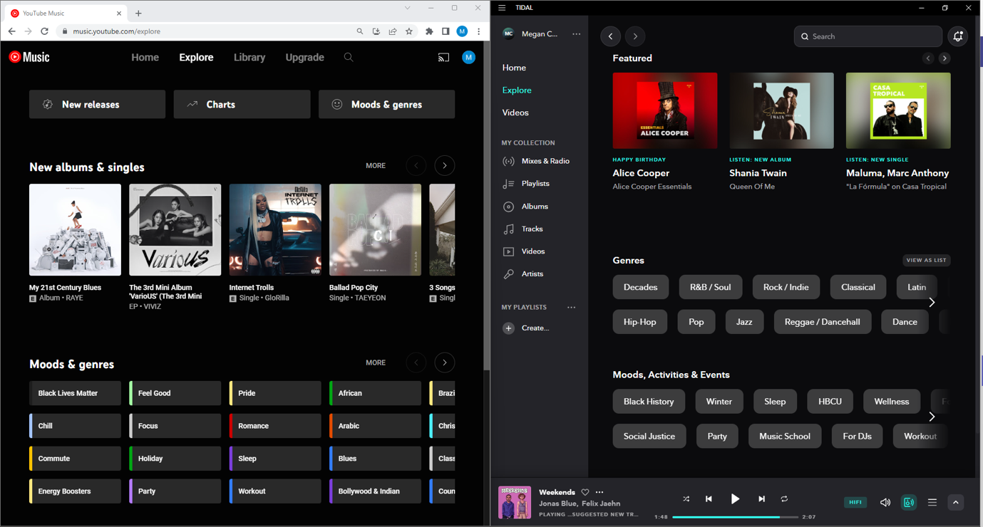

Figure 3: YouTube Music (left) vs. Tidal Music (Right) Explore Pages

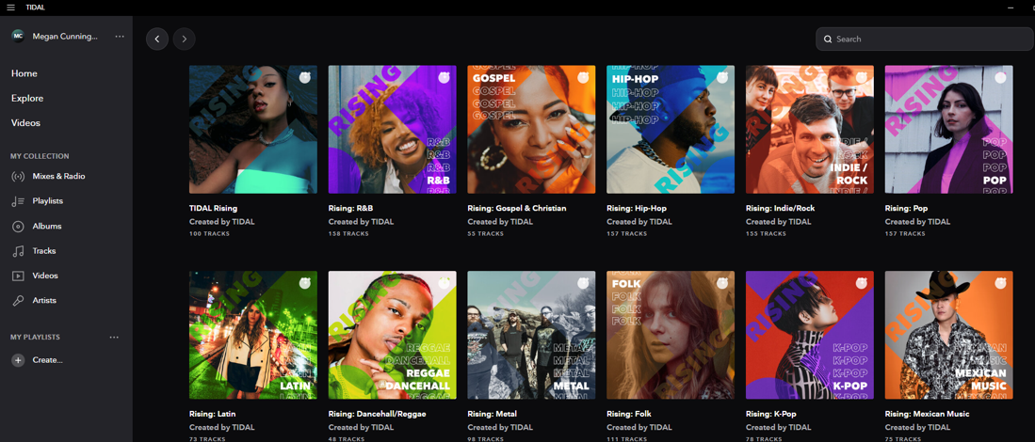

Figure 4: Tidal Music's Rising Artist Page

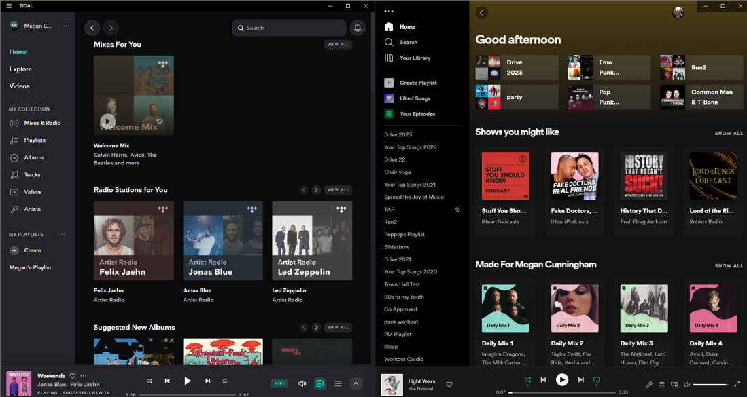

Figure 5: Tidal Music (left) vs. Spotify (right) User Interface Comparison

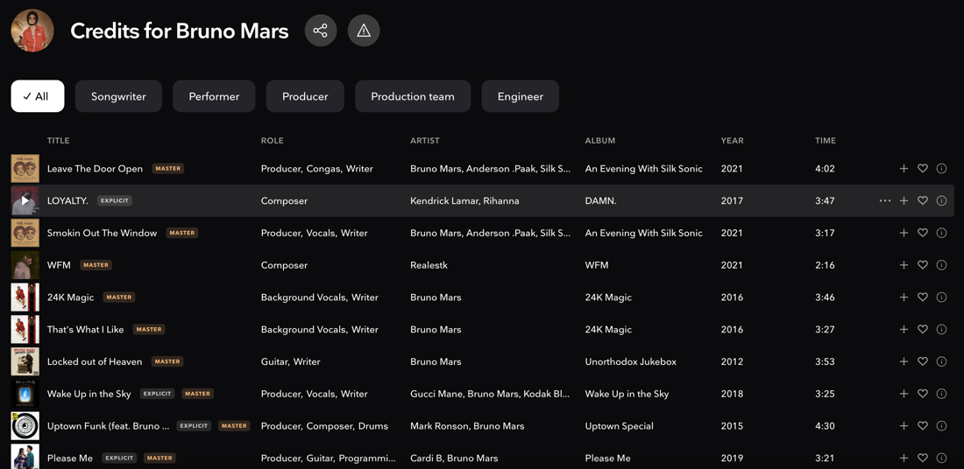

Figure 6: Tidal Music Artist Credits view

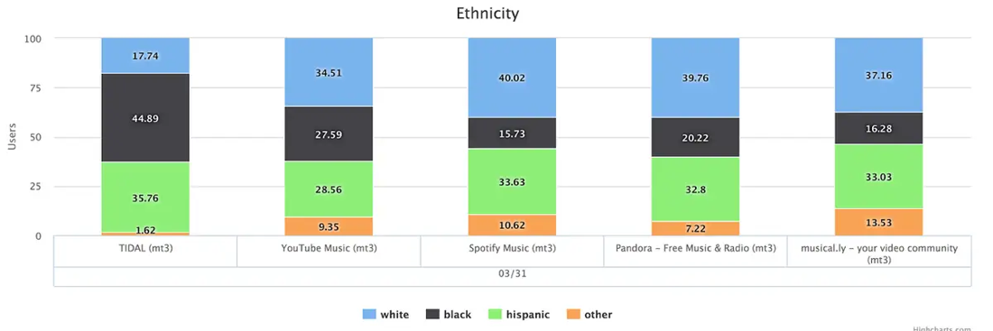

Figure 7: Business Insider article provided, via SurveyMonkey Intelligence, a comparison of ethnicity demographics across Music Streaming Services (McAlone, 2016).